ECE 310L: Microelectronic Circuits Lab

Lab 2: *I−V* Characteristics of Diode

Name:

Joe McCarver

Lab partner:

# Objectives

1. Experimentally determine the forward and reverse *I*−*V* characteristics for a standard PN diode and a Zener diode, then compare them to predicted values.
2. Plot load lines to determine diode operating points.

# Background

The ideal diode operates such that if the anode terminal is at a lower potential than the cathode terminal no current (*I*D) will flow. If the anode terminal is at a higher potential than the cathode terminal, then the diode will conduct with no voltage drop. A real diode, such as 1N4004 and 1N5230, will not conduct until a small forward bias is present and then exhibits an increasing forward voltage-drop as the diode current increases. The 1N4004 is a common power diode with a 400 V reverse voltage (PIV) rating, and should only have a small leakage current in the reverse bias mode. The 1N5032B Zener diode will exhibit a small leakage current in the reverse bias condition until the Zener voltage (~4.7 V) is reached, and then the current will increase rapidly as voltage increases.

To measure the I-V characteristics, we will use the DC power supply with a resistor in series with the diode under test as shown in Figures 1a and 1b. The resistor allows us to produce and measure a small current that is controlled by the power supply output voltage. We cannot easily control the power supply voltage to the degree needed to with a very nonlinear device like the diode. The resistor also limits the maximum current to an acceptable value.

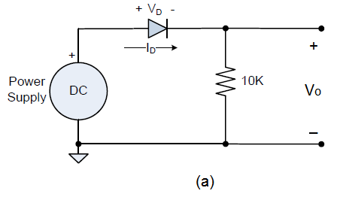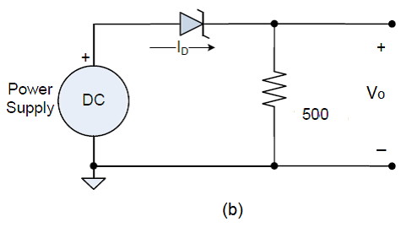

Figure 1. I-V characteristic circuit for (a) 1N4004 and (b) Zener diode 1N5230B.

Once you have collected the empirical data, you will compare it to the theoretical values. The forward current in the diode can be modeled as

, where *i*D = diode current (A)

*v*D = diode voltage (V)

*I*S = reverse saturation current (A)

*v*T = thermal voltage (V)

*n* = non-ideality constant (unitless, 1 ≤ n < 2)

# Materials

* DC power supply, HP E3631A
* DMM, Agilent E3631A
* Oscilloscope, Agilent DSO5014A
* Solderless breadboad
* Hookup wires
* Resistors: 10 Ω, 500 Ω, and 10 KΩ
* 1N4004 diode
* 1N5230B Zener diode

# Pre-Lab Assignments

Question 1. The *I* ̶ *V* relations of a non-ideal diode (*n* > 1) was measured at two points: (a) *I*D = 0.6 mA for *V*D = 0.7 V and (b) *I*D = 2.3 mA for *V*D = 0.74 V at the room temperature. Calculate:

(1) The emission coefficient *n* and saturation current *I*S;  
(2) The current *I*D at *V*D = 0.72 V.

Question 2. The SPICE parameters of a non-ideal diode (*n* > 1) is

*I*D = *I*S exp(*V*D0/*nV*t)

where *V*D0 is the voltage drop across the *p*-*n* junction. *V*D0 differs from the voltage drop between the terminal, *V*D, by the voltage drop across the parasitic resistance *r*S.

V*­*D0 = *V*D – *r*S*I*D

For the diode in the circuit shown below, the SPICE parameters are *I*S = 10-12 A, *n* = 1.4, and *r*S = 10 Ω. The current flowing through the circuit is found to be *I*D = 3.5 mA. Knowing that the thermal voltage is *V*t = 26 mV, determine the voltage between the diode terminals, *V*D.



Figure 2. Circuit for pre-lab question 2.

Question 3. In a circuit shown below, can one correctly measure the voltage across the diode *D*1 and the resistor *R*1 using an oscilloscope probe as shown in Fig. 3? Explain. How to arrange circuit components so that you can properly measure the voltage. Show the schematic (clearly label the ground and the probe).



Figure 3. Circuit for pre-lab question 3.

Question 4. The Zener diode in the circuit shown in Fig. 4 has an *I*−*V* characteristic shown in the textbox. Graph the load line on the *I*−*V* curve.



+

-

*V*D

*I*D

Figure 4. Circuit for question 4

A load line is used in graphical analysis of electronic circuits, representing the constraint other parts of the circuit place on a non-linear device such as diodes or transistors. It is drawn on a graph of the *I*–*V* relationship in the nonlinear device, called the device's characteristic curve such as the one shown in the texbox below. A load line represents the response of the linear part of the circuit as shown in Fig. 5, connected to the nonlinear device in question. It’s usually a straight line.



*I*D

+

-

*V*D

Figure 5. Linear circuit for question 4

The points where the characteristic curve and the load line intersect are the operating point(s) (Q points) of the circuit; at these points the current and voltage parameters of both parts of the circuit match.

In this exercise, analyze the circuit shown in Fig. 5 and determine the *I*D –*V*D relationship. Plot *I*D –*V*D on the same figure below and determine the intersection.

